# Project Title: Fake Medicine Detection System

# SOFTWARE ENGINEERING

## Course Teacher: Dr. Razib Hayat Khan

**Section: K**

**Group: 10**

|  |  |
| --- | --- |
| **Student Name** | **Student ID** |
| 1. JOY MATUBBER | 20-41959-1 |
| 2. MARUF SHAHRIAR | 20-42016-1 |
| 3. NAFINUR LEO | 20-42195-1 |

**Timeline Charts**

|  |  |  |  |  |  |  |  |  |  |  |
| --- | --- | --- | --- | --- | --- | --- | --- | --- | --- | --- |
| **Weeks Task** | **1** | **2** | **3** | **4** | **5** | **6** | **7** | **8** | **9** |  |
| A : Maruf |  |  |  |  |  |  |  |  |  |  |
| B : Joy |  |  |  |  |  |  |  |  |  |  |
| C : Leo |  |  |  |  |  |  |  |  |  |  |
| D : Joy |  |  |  |  |  |  |  |  |  |  |
| E : Maruf, Leo |  |  |  |  |  |  |  |  |  |  |
| F : Leo, Joy |  |  |  |  |  |  |  |  |  |  |
| G : Maruf, Joy |  |  |  |  |  |  |  |  |  |  |
| H : Joy |  |  |  |  |  |  |  |  |  |  |

**Activity key:**

A: Requirement analysis E: Testing  
B: Designing/Modeling F: Implementation/Integration phase  
C: Coding/Development G: Operation/Maintenance

D: Research H: Documentation

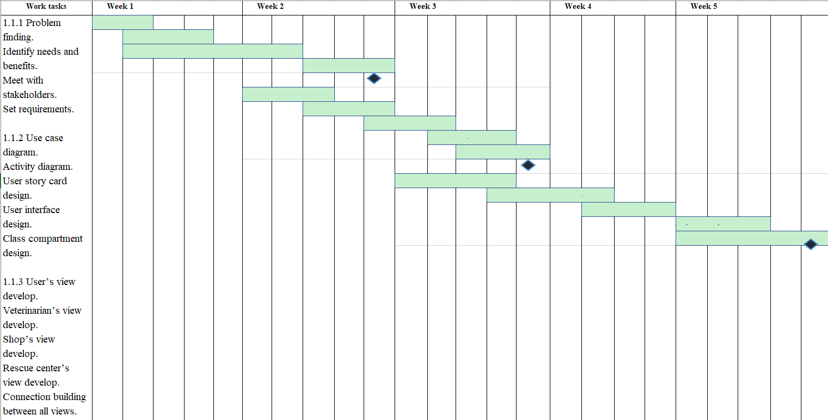

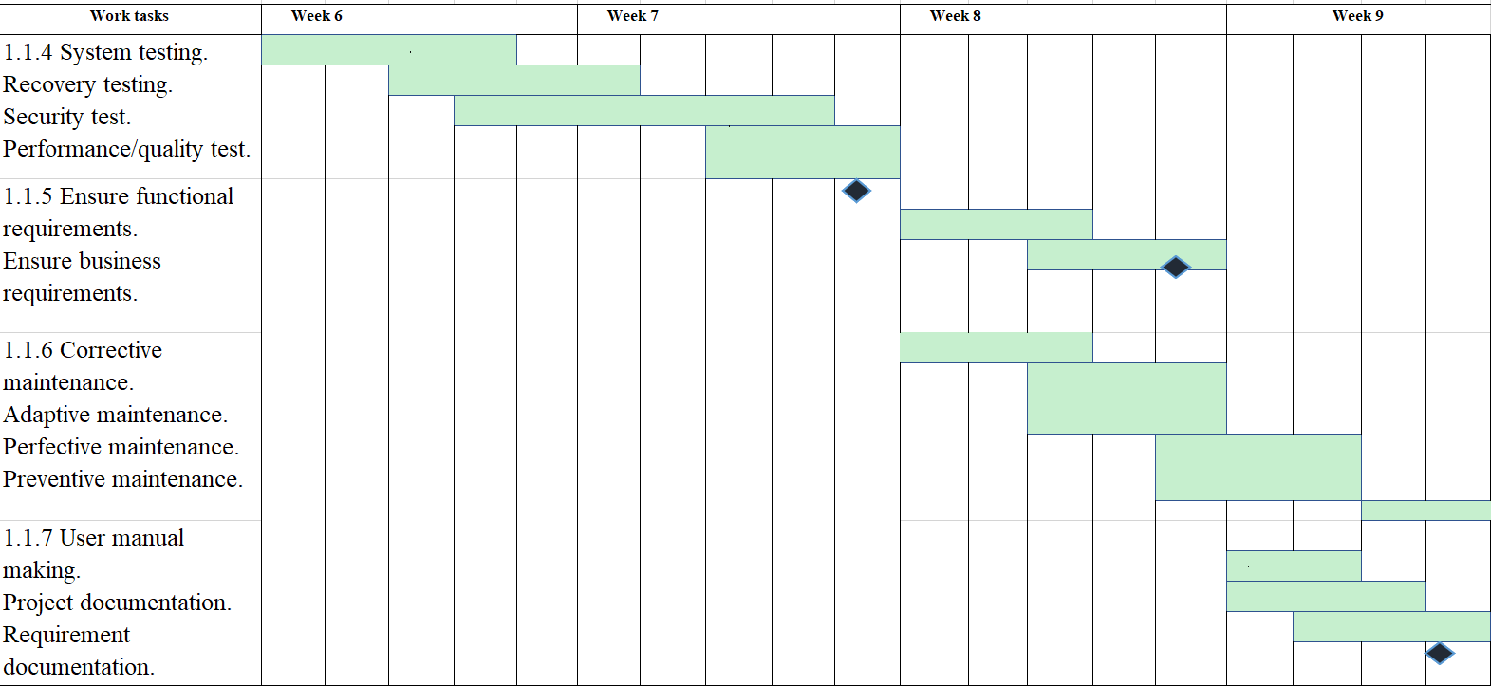

**Constructive Cost Model (CoCoMo):**

Project Type: Organic

Project Estimation :

Coefficient<Effort Factor>: 2.4

**SLOC:** 10,000

**P:** 1.05.

**T:** 0.38.

**Person Month, PM:** 2.4*(10,000/1,000)^1.05

= 26.93

**Development Time, DM:** 2.50*(PM)^T

= 2.5*(26.93)^0.38

= 8.74 months

= 9 months

**Total Working Days =** 22*9

= 198 days

= 198*8 hour

= 1584 hour

Required Number of People, ST: PM/DM

= 26.93/9

= 2.99

= 3

# Budgeting:

Developer salary of 9 months:

Per developer salary per working hour = 500 Taka

Total developer salary = 500 * 1584 = 7,92,000 Taka

Requirement analysis:

Required time = 1 month

= 22 working days

= 22*8 working hour

= 176 working hour

Requirement analysis person’s per hour salary = 250 Taka

Total requirement analysis salary = 250 * 176 = 44,000 Taka

Transportation cost: 54,000 Taka (Approximate)

Hardware expense: 1,00,000 Taka (Approximate)

Rent expenses:

Room per month = 15,000 Taka

Total in 9 months = 15,000 * 9 = 1,35,000 Taka

Total utilities in 9 months: 45,000 Taka (Approximate)

Maintenance (Till 6 months after delivery):

Cost per hour = 1,000 Taka

Total estimated time needed for maintenance = 60 hours

Total estimated maintenance cost = 1,000 * 60 = 60,000 Taka

Project manager’s salary of 9 months:

Per month salary = 40,000 Taka

Total salary = 40,000 * 9 = 3,60,000 Taka

Accountant’s salary of 9 months:

Per month salary = 20,000 Taka

Total salary = 20,000 * 9 = 1,80,000 Taka

Total expense: 7,92,000 + 44,000 + 54,000 + 1,00,000 + 1,35,000 + 45,000 + 60,000 + 3,60,000 + 1,80,000

= 17,70,000 Taka

Profit:

20% of total expense = 17,70,000 * 20% = 3,54,000 Taka

Total Budget: 17,70,000 + 3,54,000 = 21,24,000 Taka